Table of Contents

Officials ………………………………………………………………………………………………………………………

Coaches …………………………………………………………………………………………………………………………………

2016 Award recipients ………………………………………………………………………………………………

Milestone Awards …………………………………………………………………………………………………………

President’s Report ……………………………………………………………………………………………………

Secretary’s Report …………………………………………………………………………………………………………………………

Treasurer’s Report ………………………………………………………………………………………………………

Men’s 1st Grade …………………………………………………………………………………………………………………………

Men’s 2nd Grade ……………………………………………………………………………………………………………………

Men’s 3rd Grade …………………………………………………………………………………………………………………………

Men’s 4th Grade ……………………………………………………………………………………………………………………………

Men’s 5th Grade …………………………………………………………………………………………………………………………

Women’s 1st Grade ……………………………………………………………………………………………………………

Women’s 2nd Grade …………………………………………………………………………………………………………………

Women’s 3rd Grade ……………………………………………………………………………………………………………

Women’s 4th Grade …………………………………………………………………………………………………………

Women’s 5th Grade …………………………………………………………………………………………………………………………

Women’s 6th Grade …………………………………………………………………………………………………………………………

University Games – Women ………………………………………………………………………………………………

University Games – Men …………………………………………………………………………………………………………………

Club & Team based Records ……………………………………………………………………………………………………………

Games Played …………………………………………………………………………………………………………………………………

Officials

**President** – Ian Watt

**Secretary** – Karen Solley

**Treasurer** – Jarryd Hill

**Vice President** – Eloise Slip

**Assistant Secretary** – Kevin Calitz

Committee Members

|  |  |
| --- | --- |
| Matthew Moroney | Kath Coutney |
| Amanda Nabulsi | Ahad Malik |
| Liam Dixon | Alli Hendricks |
| Edwina Pendlebury | Jack Dean |
| Ange Birkefeld | Jake Misner |
| Jimmy Birkefeld | Kathrine Bond |

Coaches

Coaching Director – James Birkefeld

1st Grade Women’s coach – Nellie Morton

2nd Grade Women’s coach – Iain Watt

3rd Grade Women’s coach – Owen Logan

4th Grade Women’s coach – Alex Braud

5th Grade Women’s coach – Krista Jenkins

6th Grade Women’s coach – Kath Courtney

1st Grade Men’s Coach – James Birkefeld

2nd Grade Men’s Coach – Kevin Calitz

2nd Grade Assistant Coach – Amanda Nabulsi

3rd Grade Men’s Coach – Marcus Reed

4th Grade Men’s Coach – Andrew Herron

5th Grade Men’s Coach – Colin Haycroft

Awards

**Perpetual Awards**

**Kirsty Gibbs (Club person of the year)** – Amanda Nabulsi

**Joe Dean Men’s First Grade player of the year** – Luke Kliendienst

**Nina White Women’s First Grade player of the year** – Claire Purnell

**Ralph Scott Coaches Development Award** – Kath Courtney

**Ian Jessup Top goal scorer Award** – Roy DeBeer

**Women’s Awards** **Men’s Awards**

*1st Grade*

Players player – Claire Purnell Players player – Luke Kliendienst

Coaches Award – Emma Hislop Coaches Award – Owen Logan

*2nd Grade*

Players player – Micki Muller Players player – Darren Cox

Coaches Award – Emma Spencer Coaches Award – Kalervo Gulson

*3rd Grade*

Players player – Alex Walters Players player – Joey Crane

Coaches Award - Susannah Gynther Coaches Award – Greg Ford

*4th Grade*

Players player – Maddie Dockrill Players player – Tim Austin & Tony Hannon

Coaches Award – Beth Clarke Coaches Award – Jackson Bush

*5th Grade*

Players player – Pia Stutchbury Players player – Ben Barker

Coaches Award - Taylah Murray Coaches Award - Hemadri Bargoti

*6th Grade*

Players player – Kearney Byth

Coaches Award - Louisa Brammall

Milestone Awards

50 Games

|  |  |  |
| --- | --- | --- |
| April Webster | Gina Kee | Ryan Evans |
| Zoe Reynolds | Jessica Knight | Owen Logan |
| Eloise Slip | Steff Fenton (1s) | David Brown |
| Amanda Bush | Ellie Evans |  |

100 Games

|  |  |  |
| --- | --- | --- |
| Mairead Brannigan | Ahad Malik |  |
| Hina Khan | Nathan Thomson |  |
| Julia Papahatzis (1s) | James Nugent |  |
| Hemadri Bargoti |  |  |

150 Games

|  |  |  |
| --- | --- | --- |
| Thomas Pacey | Iain Watt | Merv Turner |

200 Games

|  |  |  |  |
| --- | --- | --- | --- |
| Susannah Gynther | Jeremy Chia | Jack Dean | Aaron Chang |

300 Games

|  |
| --- |
| Kasey Proszenko |

President’s Report – Iain Watt

2016 another huge year, despite massive growth the 2 preceding years this year did not allow for consolidation of the good work but rather saw our club add another male team. Taking us to 5 men’s and 6 women’s for a total of 11 teams and over 180 HNSW registered players. On top of the growth in numbers the standard of hockey played by this club has also gone up each year and 2016 represented another step on this journey. With 2 of our Metro League women’s teams being promoted a grade and all 4 men’s teams being promoted from the grade they played in 2015. With 1st Grade men finally making the leap into Premier League Sydney Hockey.

We have continued to attract new players to our club though the university’s O-week and club member inviting their friends. Though this year we started to see players coming over directly to Mac from their junior clubs. This represents the clubs reward for a lot of work done by many in building the clubs brand within the hockey community, getting our coaches out to junior sessions and taking rep sides. All to make Mac Uni Hockey a club that is taken seriously and one that top talent can play for without limitations. This was no more evident than in the number of Maguts taking part in the state championships, and 2 junior members making the AAP squads.

The on field results were not what we have come to expect over the last 3-4 years we were unable to secure any premierships in Men’s or Women’s this year. Though despite this, the year was still a huge success for the club, we still raised money for the McGrath Foundation though our annual pink week. All players could be seen supporting one another at games on the weekend. Something that is a true part of this great club is the bond between club members not just team members but rather as a collective. We are able to be more than just a sports club we can be support system each other both on and off the field and I was fortunate enough to see this in action this year.

2016 was not without it challenges though, these 11 teams now train on less turf space than we once had for 6 teams. As outlined in the Treasurer’s report this has been due to a decrees in funding from the Uni. While we have been able to fit everyone in this year it is not sustainable into the future. So it has become paramount moving forward that more funding be secured for additional training and safer training. The need for more training space is a huge encouragement that we have built a club of people committed to hockey and to improving themselves.

The work load of looking after 11 teams is beginning to burn out committee members, coaches, helpers before the club can reach the end of the season, while these people cannot be thanked enough for the work that they do behind the scenes. Giving up their time for others it does have a toll that all club members should be aware of what needs to be done as the more helping hands then the slower the burn outs or lack of it entirely which will allow our club to perform to its best year after year. I would like to add my thanks to a hard working exec and committee for 2016 without whom this year would not have been possible.

2016 has been another year of improvement with many lessons learned along the way, it is my hope and belief that the Maguts will back the stronger for it in 2017 and that we will remain a club that believes in every player from the weekend warriors to the elite and to all those in between just giving it their all. MUHC has been and will be a place for anyone who loves this great sport.

|  |
| --- |
|  |

Secretary’s Report – Karen Solley

As always my dear maguts and magettes, being on your executive committee and striving to make each season better than the last is a pleasure. Yes, there’s the daily grind – but that’s only part of it. For the most part, it includes being with great people who are keen to be part of something bigger, and THAT’S why I love it. I can look back at the towering heights of our 2015 season of success from this year’s season with slightly fewer take-home medals, and know that we had a good year.

My main man Iain Watt will have told you all about our on-field successes this year, but I’d like to take a bit of your time to shine a spotlight on some of the behind the scenes grunt that made the fun of this season possible.

Starting off with our New Players Night – the inaugural night of frivolity for any of our new uni recruits from O-Week. Thank you to our tireless social and university engagement committee members who spread the Magut Vibe at O-Week way back at the front end of this year. The Ranch always loves to help us welcome in new players into the fold. Next it was our annual City vs Country “Spewy’s Cup” and Rocks Pub Crawl and there was no doubt our 2016 social season was well underway. The good vibes continued right through Pub Golf and our first Trivia Night with Pennant Hills Juniors, not to mention our fast-growing Pink and Heritage Weeks and of course, the most prized social event of the year - Preso Night.

Thanks to the persistence of our great committee we are now benefitting from the second year of our Social Memberships, allowing us to provide quality social events without the financial run around. With Ellie Slip as Vice President we have started to stream-line our event planning and now have systems in place that will ease the administrative and organisational burden of running these events in future. Go us!!

It’s been a bonkers year in terms of merchandise and uniforms. Thanks goes Canterbury for setting up a wonderful new relationship with the Australian Defence Force (read – accidental stuff up on blending our orders) our new recruits didn’t feel the soft and cosy freshness of hoodies and hurricane jackets this season. Our sincerest apologies for this dear maguts; we will be working tirelessly to ensure your bodies are covered head to toe with appropriate magut merch and uniforms next year.

This year we also enjoyed the steady stream of facebook banter that flowed out of our second MUHC Fantasy League season. Congrats to Lenny who took out the Manager of the Year award. Like last year, the league ensured the weekly results of all teams were important, players became invested in the results of other grades and the efforts of others on-field, and most importantly, bonds between all Maguts and Magettes were strengthened.

Lastly, as I sign of on another spectacular year of Magut Awesomeness, thank you to all those who holler out “Hey Solley” at me when I’ve been hanging around matches and social events. It’s been a bit of a strange year for me being on exec but not playing. I’ve learnt a very important life lesson this year: that whenever you don your #magutmerch you are automatically part of one great big magut family. Thanks guys!!

Treasurer’s Report – Jarryd Hill

**Financial Summary 2015 & 2016 Season**

**Overview**

The last two seasons at MUHC have been seasons of financial repair for the Club. Inheriting a deficit in the 2014 season (see cash balance) the focus for the last two seasons has been to simplify the financial management of the Club including the implementation of key policies specifically targeting the overall cost recovery of social functions.

**Significant Changes to financial position/policies over the past two seasons**

* University funding reduced from $23,975 in 2014 to $14,000 per annum across both 2015 and 2016 seasons
* All social events run at a net gain across both season
* Sponsorship up from $2500 in 2014 to and average of $5300
* Merchandise purchased to order rather than stock
* Fees budgeted for full recovery of all costs (including assumptions of premiership Jerseys)

**Cash Balance Overview**

Cash Balance at end of 2014Season: $57,4661

Cash Balance at end of 2015 Season: $63,2512

Cash Balance at end of 2016 Season: $67,0463

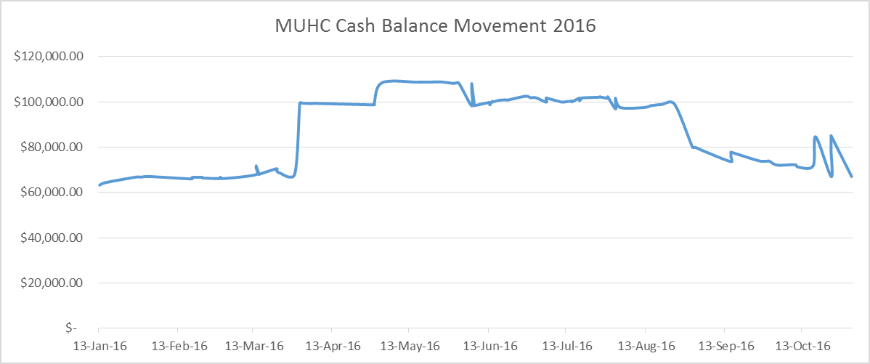

1. *Adjusted for outstanding invoices and UNI bank error in MUHC favour*
2. *Increase in cash balance brings club account in line with starting position in 2014*
3. *There will be a Nil net change to this balance prior to next season (Supplier refunds to offset Merch refunds)*

**Budget Outlook**

Fees for the 2017 season will be again set to fully recover costs, at this stage there will be little change from the 2016 season but will look to invest in more turf time.

**Investing for the Future**

Gain generated from the year will be used to implement an ecommerce platform allowing for the accurate collection and recording of all club payments (a system that has not been in place since the Uni changed their fee collection processes mid 2015.

A full list of transactions is available on request.

Jarryd.

Men’s 1st Grade – Jimmy Birkefeld

**Position**

|  |  |  |  |  |  |  |
| --- | --- | --- | --- | --- | --- | --- |
| **Played** | **Wins** | **Loses** | **Draws** | **Goals For** | **Goals Against** | **Position out of** |
| 17 | 5 | 11 | 1 | 34 | 53 | 10/12 |

After 3 premierships and as many promotions over the past 3 seasons, it was time for the men’s first grade side to play premier league 2 for the first time in the clubs history, what an amazing accomplishment and a just reward for the hard work put in and the enthusiasm shown by a dedicated group of young men.

We always knew it would be a big step up and a challenge that needed to be met head on, the team acquitted themselves well across the entire season, being competitive in each and every match, we definitely let a number of games slip through our fingers, and I think we can definitely pinpoint areas from these matches that definitely need to be improved upon going into next season.

I think winning moved the goalposts on how the club and indeed individual teams viewed success and it is perhaps something we need to re-consider and take with us as a team and club moving into the future.

A good year for a team is achieved when each and every member of the team enjoys turning up for training and games, attending team and club functions, where the success or failure of the days game are shared equally but not dwelled upon.

Players in a good team do not play first and foremost for themselves they play for the benefit of the team.

So if you ask me if I think this year’s team was successful, I would say it was.

We lost some important members, but we welcomed and embraced many new players and friends into the fold who will help us build and find even more success in the future.

You developed and improved as a group and encouraged each other along the way, this group will only get better and more determined with another season together.

It was a really good first season of Prem 2 and I am looking forward to working smarter and harder together next season and seeing what we can achieve.

Thanks for an almost enjoyable season.

Men’s 2nd Grade – Kevin Calitz

**Position**

|  |  |  |  |  |  |  |
| --- | --- | --- | --- | --- | --- | --- |
| **Played** | **Wins** | **Loses** | **Draws** | **Goals For** | **Goals Against** | **Position out of** |
| 17 | 11 | 4 | 2 | 40 | 22 | 3/12 |

**Finals Series**

Elimination Semi Final: Macquarie University vs Sydney Uni Loss 1-0 in extra time.

The expectations for the 2016 season couldn’t have been much higher, we had recorded the best defensive records, and made 2 grand finals, in a row, won last year’s grand final against a seemingly unbeatable Sutherland, and now we had been moved up yet another grade to Premier 4. This year would test how far second grade men had come in a relatively short space of time.

However, Amanda and myself felt we were in good form leading into the season, due to some great recruitment and a solid preseason. We started the season off with a resounding 3-0 win over Sutherland down in Sutho (Not the Sutho team we played last year, as they had in fact moved up 2 grades), and we would go on to win 3 out of the next 4 games (with a single draw), only to come crashing back down to earth with a 3-1 loss to Manly.

For the remainder of the regular season we would end up only losing only 3 more games, twice to Ryde, the eventual Minor Premiers (in extremely frustrating games where we definitely let ourselves down), and once more to Manly (our bogey team). However, in our two fixtures against the eventual Major Premier winners, UNSW, we would record a draw and a win which indicated we had a good chance of making the grand final and potentially winning it.

We would end the regular season in 3rd place, having won 11, drawing 2 and losing only 4 games - an incredible performance considering the jump in standard this year, as well as the many players we had unavailable throughout the year due to (many) injuries and personal commitments.

Our first knockout game was played against Sydney Uni who we had beaten twice in the regular season, however they had some older experienced players in their squad so we couldn’t underestimate them. After regular time the game was still tied up at 0-0, and our frustrations at having most of the possession and opportunities to score was starting to show. If the game ended in a draw we would go through as the highest placed team, but in the final drop offs segment of 7vs7 we conceded a short corner as the final whistle blew. The tension was palpable and we were effectively seconds away from moving on to play UNSW in the next round, only to concede what must be said, was one of the better short corners we had faced all year. An outstanding drag flick ended our season for 2016 and the disappointment was evident from everyone.

Amanda and I couldn’t be more proud of what the guys achieved both on and off the field, we had an amazing team environment at training sessions, in the change rooms and generally wherever there was a Mac Uni event, and we played competitive and hard, but fair hockey. I also speak on behalf of Amanda when I say it has been an absolute pleasure being a part of this team and we wish you all the best for next year.

Men’s 3rd Grade – Marcus Reed (player & fill in coach)

**Position**

|  |  |  |  |  |  |  |
| --- | --- | --- | --- | --- | --- | --- |
| **Played** | **Wins** | **Loses** | **Draws** | **Goals For** | **Goals Against** | **Position out of** |
| 16 | 6 | 7 | 3 | 23 | 19 | 5/9 |

The first 4 weeks were... interesting.  
Off to a flyer with 4-0 over Sutherland, the following week we were made to work for 1-0 over SydU. Week 3 became the most inspirational game of the season: 1st time against St. George. 1 sub, holding 1-all until inside 15 to go, we were just run into the ground yet still able to fashion chances. The seed self belief was sewn that night, we had the ability. Whilst week 4 might've been the worst for the year with Bentstix running rampant to spank us 2-4. Mistakesville. Population: Us.  
  
What continued showed where the level of competition was at;  
- Minimisation of mistakes almost guarantees a shut out  
- Finishing chances holds greater importance  
- High tempo gameplay makes the opposition panic and struggle  
  
We ebbed and flowed these points, collecting draws (2 against the top 4) and 1 goal losses for half the season, but whilst the results may have been honest of the games they sure didn't reflect of what the team was producing because at no point did we get out played and in all games we fashioned enough chances to take the points. Never playing poorly, just made lots of little mistakes that sooner or later hurt us.  
  
The run into finals saw much more of we were capable of from the outset, either grinding out 1 goal victories, dominating teams off the park, manipulating opposition play to our advantage and generally getting into the rhythm of swift and smart hockey.  
Alas our finals berth came down to needing a win in the 2nd last round which wasn't to be. They got a freakish (possibly dubious) goal and we just could not find the target despite a billion chances.

Final round was the most anticipated of the year since round 3, the rematch, and WHAT A GAME! Absorbed confidently everything they threw at us whilst in return they had to break down our attacks rather than being able to stop us. Unfortunately, for the second week in a row we just could not put it away whilst St. George finished their one half chance from open play, and after 28 short corners they finally changed their hitter and put another one away.

Against the top 4 we easily went toe-to-toe with the minor premiers (St.George - Randwick) and GF losers (Ryde - Hunters Hill) but unable to claim points off them.  
We easily took 4 points from 6 from the GF champions (Briars) and despite playing all over 4th place (Monterrey) their 6 man defense misered a solitary point. We bagged all 6 points off Sutherland and Sydney Uni. Whilst it was a bit of a mixed bag with Easts, and Bentstix.

Fifth in the end, but could very easily have been third... next year?

A massive thanks to all the coaches who put up with us. :D  
To those who doubled down from 2s, thanks again and we hope you enjoyed yourselves :)  
For those who stepped up throughout the season, again many thanks and pat yourselves on the back as well for none of you looked out of place. Hi5!  
  
Marker laid Thirds. Lets begin 2017 with our best from 2016... I'm keen.

Men’s 4th Grade – Andrew Herron

**Position**

|  |  |  |  |  |  |  |
| --- | --- | --- | --- | --- | --- | --- |
| **Played** | **Wins** | **Loses** | **Draws** | **Goals For** | **Goals Against** | **Position out of** |
| 17 | 13 | 2 | 2 | 70 | 17 | 2/10 |

**Finals Series**

Semi Final: Macquarie University vs Briars (4-3)

Grand Final: Macquarie University vs Briars (0-3)

The Macquarie University men’s fourth team (of five) played in the Sydney Hockey Association Sydney League 4th division for 2016, a grade higher than the previous season. I took over the coaching of the men’s fourth team from Thomas Pacey this year and had big shoes fill with the team taking out the premiership in 2015.

With the influx of new players across the club resulting in the inclusion of a fifth team for the first time this season, the fourth grade team had many new faces. We completed the regular season in second place on the ladder with the best defence in the division only letting in 17 goals while scoring 70 goals ourselves (second best in division).

To reach the finals we used 27 different players across our 17 games and had over 14 people hit the score sheets. While the goal scorers get the written recognition our defensive unit saved many goals across the year which was reflected in the lowest goals against total described above.

Two notable games in the year were the game against Ryde at Homebush during the regular season and Briars at Pennant Hills during the finals. The Ryde game became somewhat willing with Peter Kohlhagen being hit in the head by a Ryde player’s stick. This action and fallout that followed could have seen the team implode but instead we decided to out-hockey Ryde and put away four goals to bury them.

The first of our two games against Briars in the finals was the other stand out. Having lost 4-0 in our two previous encounters in the regular season, we implemented a completely new defensive structure for the finals. This new style, which we had only been using for a couple of weeks was frustrating Briars and cracks began to show. While we were ended up 2-0 down in the first half, coming into half time we managed to score a goal and put more doubt in their mind. We ended up putting four goals in a row in before eventually running out winners 4-3 to proceed straight to the grand final. The skill of the team to resist the pressure, the way we worked as a team and the support we had on the sideline from the club was amazing and certainly a game we’ll never forget.

Unfortunately the second time we met Briars in the grand final, the luck did not fall our way. In such a competitive game where one goal could have turned the tide, the luck marginally fell the other way at crucial stages. This resulted in us being runners up for the 2016 season. The fact that Briars were the benchmark team across the year and to have such a close game shows the improvement in the team across the year (recognised within the club and from our opposition). While losing the grand final is gutting, how close we were is very encouraging for next season where the team should be aiming to take the winners medals in the 2017 grand final.

Men’s 5th Grade – Colin Haycroft

**Position**

|  |  |  |  |  |  |  |
| --- | --- | --- | --- | --- | --- | --- |
| **Played** | **Wins** | **Loses** | **Draws** | **Goals For** | **Goals Against** | **Position out of** |
| 18 | 11 | 4 | 3 | 60 | 38 | 3/10 |

Macquarie Uni Mens 5s.

Kicking off training for the season, it looked like we’d have a player list of ~19. Great, not likely for shortages on any given week. Always a good sign and something lots of clubs would wish for. Into the first round, we scraped a draw against Bankstown. Still coming back from 3-1 down to level in the last couple of minutes showed good pluck. A win the next week and with extra recruit Roy leading the strikers we built (overbuilt) confidence for a complete pantzing by Wests WTF! Well on reflection, always the hoodoo for 5s and with Joe just making it off his deathbed to play…meh.

Sitting back and taking it all in at that point, I assessed the team as probably being middling in the standings, maybe looking for a 5 th or 6 th at end of season; a year of consolidation after last year’s premiership.

Well, roll on from there! The guys clicked in, tacking training into the games and we put togther a string of wins, getting up to 2 nd on the ladder, the only team ahead the unbeaten Briars. The top of the table clash came, and so did the rain. We were ready, out on the pitch and good to go, but the umpires sided with the wusses and abandoned play for the day.

So the table sat fixed with the Maguts in 2. Eventually we had our chance to play them, but went down. Still gave us the chance to see what they had….didn’t seem to be a lot, and looked forward to seeing them the next time with the Frij back on board. The wins continued to come until…you know that game you have in a season, the one to forget, the one where…. Ours was vs Syd Uni. They turned up with 8. No Goalie, 3 rd bottom team. Pfft should hose them. Got 1 – nil up before their GK arrived. With plenty on the bench and them short, should have been a doddle, but some penalty corners later, game was lost at 1 – 4. Yeah well let’s put that one behind us.

One thing about a loss like that, it gives a fair kick in the butt for motivation. We had the re-play of the washed out Briars game the next day. Sunday. We let them score first, seemed the thing to do, then we had a chat about things and shuffled some players at half time. That and a bit of motivation, haha, 3-1 win to the Maguts and Briars cop their first loss for the season. Nice!!!

Only a couple of rounds to go and we’re off to Kyeemagh. Doesn’t everyone hate going to that ground! The game before us is Briars vs Wests. West demolish Briars. Yep, Briars have nothing much going on. We need to beat Manly, second last, to shore up second for the season and have the double shot. Yeaah, well we play like rubbish, plenty of shots and just as many misses. 1-1 draw.

Can’t believe it! Drops us level with Wests on points, but down to 3 rd on ladder, courtesy rd 3’s 8-1 loss. And that’s where 5s finished the rounds, 3 rd spot. Yep, well that’s OK we’ll take it from there.

Come on Ryde (4 th spot) bring what you’ve got! Semi final vs Ryde. Good lead in training sesh. Everyone focussed and pumped for the game. Everyone running hard and working well. 3 – 1 win. Yeah!! Nice! Love to beat them. They later post on FB that we doubled up players from 4s. Yep, we did! Ben Barker played his first game of 4s that day. Meanwhile on the next pitch, Briars vs Wests goes to extra time drop offs. A draw after extra time, Maguts will play Wests the following week.

Prelim final is hard fought. We know the strategy, and play it well, just battle to get the ball into the goal. Wests on the other hand use their proven strategy. Vu hit to centre half with a modicum of talent but not so fit, hit to the pirate sitting on Joe Dean’s toes. The scoreboard shows that they scored and Maguts didn’t. We end the season with a 3-1 prelim final loss.

Wrap up: Maguts 5s. 12 regular players including 2 that played all rounds, Joe and Koos. Another 7 that played about half a season, some exchange between 4s and 5s, 2 with injuries. All in all, a really good result for a team that was looked at as maybe the field contender early on in the season.

Women’s 1st Grade – Janelle “Nellie” Morton

**Position**

|  |  |  |  |  |  |  |
| --- | --- | --- | --- | --- | --- | --- |
| **Played** | **Wins** | **Loses** | **Draws** | **Goals For** | **Goals Against** | **Position out of** |
| 18 | 5 | 8 | 5 | 27 | 29 | 7/10 |

2016 was a year of new, of integration and of development. New coach, and the addition of 4 new young U/18, squad or state level players. The 12 established Macquarie uni players, prided themselves on their friendliness and inclusive way and made integration of the new players easy on and off the field.

To have 16 players each week, at times we had div 2 players playing up, or the inclusion of quality imports. My plan was to develop this group of quality young players to play a passing style of game that requires a high work rate, speed, discipline and knowledge of the planned structure and patterns of play. They embraced the new learning’s and as the season progressed the development and greater confidence, became obvious to all.

RESULTS

Finished 7 th out of 10 teams in ML2. With 5 wins, 5draws and 8 losses. Although the position was fairly stable at 7 th , for most of the season the last 6 games mac uni was a force against the top 4 teams. The style of play and patterns of ball movement and team cohesion was starting to click and the team looked really good.

THE TEAM

GK Kate Studd, Claire Purnell, Angela Birkefeld, Stephanie Fenton, Edwina Pendlebury, April Webster, Allison Hendriks, Phoebe Crosthwaite( half season), Krista Jenkins, Emma Hislop, Jemma Purshouse, Scout Walker, Neva Williams, Helena Tobbe(Half season), Julia Papahatzis, Xanthe Dwyer, Leigh Becktel.

DIVISION 2 GIRLS PLAYING UP.

Amy Locke, Libby , Ellie Evens

IMPORTS

Naomi Duncan, Brooke Welsh, Natalie Strawhorn, Megan Higgins, Liana Smith

I look forward to next season, as I see a team, if it continues to develop in fitness,skill, knowledge, and culture will be very competitive in ML2 in 2017.

Women’s 2nd Grade – Iain Watt

**Position**

|  |  |  |  |  |  |  |
| --- | --- | --- | --- | --- | --- | --- |
| **Played** | **Wins** | **Loses** | **Draws** | **Goals For** | **Goals Against** | **Position out of** |
| 18 | 3 | 9 | 6 | 11 | 33 | 9/10 |

2016 saw 2nd grade accepted back into ML4 a reward for constant performance year on year in ML5. But still represented a big step up for many of the girls.

This year also saw a number of new girls make their way into the or back to the 2s from the year before. But with a strong returning core of players hopes were high to start the season.

The start of the season was strong enough with our on field efforts setting a high standard for effort and backing up your team mate, we even pulled in a couple of wins and draws.

Through the middle of the year we hit the mid semester break and just getting 11 girls on the field each week was a challenge, this unfortunately took its toll on the team’s energy and our ability to train hard on Monday nights. But the effort given on the field was always a source of encouragement that we could mix it with the best of ML4.

ML4 was was of the tightest competition in SWHL this year with only a couple of points separating 3rd from 7th. While this team did struggle to get the winner in some games. We more than showed we were up to the level of ML4 by the end even taking points of the top of the table late in the year.

Given this the future looks bright for this team in 2017, if we can get a consistent team together and show the desire to play for each other that was evident at the end of the year.

Women’s 3rd Grade – Owen Logan

**Position**

|  |  |  |  |  |  |  |
| --- | --- | --- | --- | --- | --- | --- |
| **Played** | **Wins** | **Loses** | **Draws** | **Goals For** | **Goals Against** | **Position out of** |
| 18 | 5 | 8 | 5 | 27 | 29 | 7/10 |

After moving up a division from the 2015 season, to ML 5, the team looked to the challenge with both awe and excitement.

The team was an outright mixed bag, with the level headed defence of Sue, Kasey and Kirra, to the enthusiasm and zeal of Millie and Anna and Rosie.

The season started off as expected, but as the season progressed each member of the team found their feet and by the end of the season they all (I hope) enjoyed turning up and playing for each other.

The positive team attitude definitely showed dividends on the field, as noted through our scores, and the progression of the team was in full flight as the ladies proved they were no easy beats.

Our player’s player for the year was Alex Walters, who was undoubtedly one of the most consistent and hardest working players.

As the year came to an end, I could not be happier with how the team, knowing that they all enjoyed their season, and wanted to turn up week in week out for each other regardless of the result.

Women’s 4th Grade – Alex Braud

**Position**

|  |  |  |  |  |  |  |
| --- | --- | --- | --- | --- | --- | --- |
| **Played** | **Wins** | **Loses** | **Draws** | **Goals For** | **Goals Against** | **Position out of** |
| 17 | 2 | 14 | 1 | 15 | 51 | 8/8 |

|  |
| --- |
|  |

2016 4th grade women's had a bit of a disjointed year for the team with a coaching switch early and some player movement. The girls competed hard all through the year in was ultimately a tough division against some good hockey teams.

While we finished towards the bottom of the ladder, the standard of the hockey improved dramatically throughout the year as the girls begun to understand and employ aspects such as post ups, switching and creating 2 on 1's.

In regards to development points, I firmly believe some of the girls could be playing 2-3rd grade at some point in the future with the right coaching. What they require is a coach who can teach and develop the basics correctly.

Selections seemed to be a bit confused this year with a lot of player movement. Always a tough job but not sure if there is a better way of doing it?

Finally a big thanks to the girls for their efforts throughout the year and to our assistant coach lovers.

Women’s 5th Grade – Krista Jenkins

**Position**

|  |  |  |  |  |  |  |
| --- | --- | --- | --- | --- | --- | --- |
| **Played** | **Wins** | **Loses** | **Draws** | **Goals For** | **Goals Against** | **Position out of** |
| 17 | 4 | 5 | 6 | 13 | 16 | 6/9 |



Women’s 6th Grade – Kath Courtney

**Position**

|  |  |  |  |  |  |  |
| --- | --- | --- | --- | --- | --- | --- |
| **Played** | **Wins** | **Loses** | **Draws** | **Goals For** | **Goals Against** | **Position out of** |
| 15 | 2 | 10 | 3 | 13 | 37 | 8/9 |

The Macquarie University Hockey Club women’s 6th grade team competed in the Sydney North Women’s Hockey Association D division competition in 2016. We fielded almost a completely new team this year with many of the players new to the club. We had a team of 19 players which led to an issue where people thought we’d have enough players and thus did not commit to playing all games, thus some weeks we found it difficult to field a full team and develop any team cohesion throughout the season. Of the 15 games we played we had 10 losses, 3 draws and 2 wins placing 8th out of 9 teams. Our leading goal scorer for the season was Aimee with 6 goals, the rest were spread around the team, it was great to see so many people scoring goals. The Coaches award went to Louisa Brammall and Players player to Kearney Byth.

Over the season the basic skills of each player improved which showed in our game play with improved linking and passing between players towards the end of the season. We kept the majority of our games to a low score line with a strong defensive line up with Jess making some great saves in goal. Kellie and Shibhon provided good cover at the back with Laura, Alley and Bec cutting out the attackers strikers in the half line. Aimee provided a solid centre, despite wanting to be in a more attacking role and was given the opportunity when Kearney stepped up as Centre Half with her never give up attitude. Our Inners, Louisa, Emily and Myrsina moved the ball well from the halves to our strikers, where Michelle, Ella, Charlotte, Manisha and Kate gave it everything to get the ball in the goal. One of the best moments of the season was Kate’s goal celebration, so happy about her goal and absolutely hilarious.

As a team we always gave it 100% and never gave up even in the last minutes of a game so can’t ask for more than that as a coach, was good to see the improvement throughout the season.

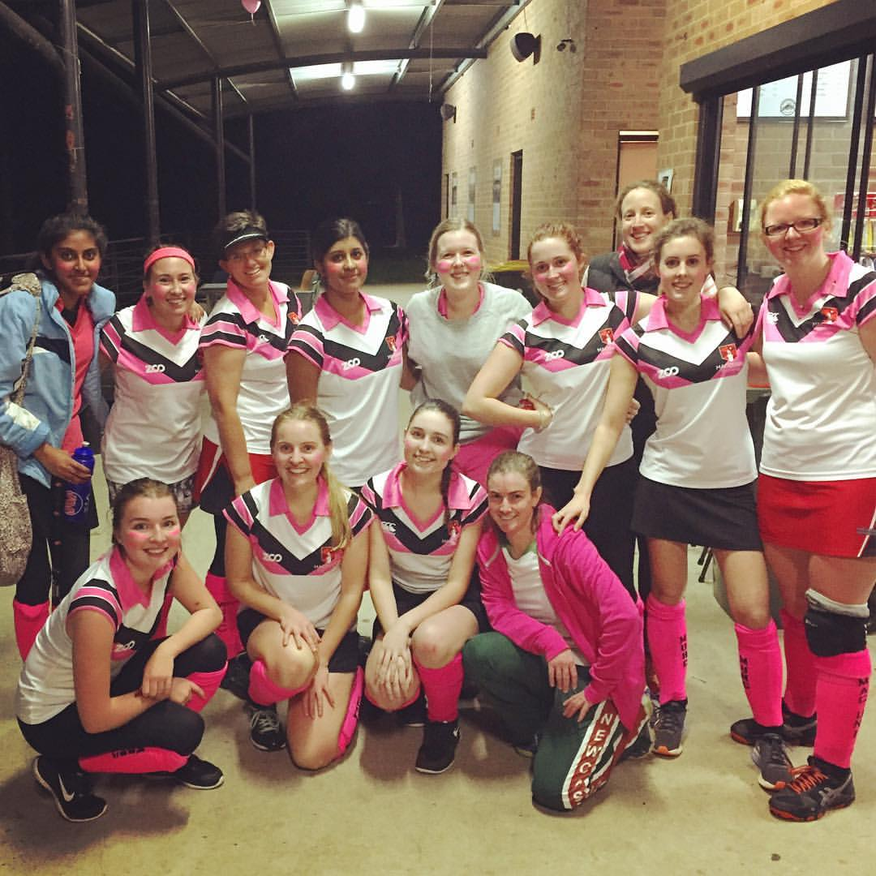

Unigames – Women

Unigames – Men

|  |  |
| --- | --- |
| Joe | Dean |
| Hemadri | Bargoti |
| Merv | Turner |
| Dave | Brennan |
| James | Power |
| Jack | Lever |
| Jack | Haycroft |
| Colin | Haycroft |
| Matthew | Moroney |
| Nick | Murdoch |
| Koos | Kruger |
| Alex | McCulloch |
| Matthew | Pullen |
| Chris | Loveday |
| Andrew | Cottee |
| Tom | Reilly |
| Elijah | Rayner |
| Lenny | Furtado |
| Ahad | Malik |
| Andrew | Roumanos |
| Thomas | Pacey |
| Robert | Misner |
| Tim | Austin |
| Owaise | Riaz |
| Simon | Pullen |
| Peter | Kohlhagen |
| Ben | Odgers |
| Tony | Hannon |
| Ryan | Evans |
| Cameron | Hunter |
| Robert | Ashcroft |
| Nils | Hackett-Hansson |
| Jeremy | Nugent |
| Marius | Levitt |
| Michael | Jordan |
| Jacques | Nel |
| Chris | Powys |
| Ben | Devaney |
| James | Manning |
| Riley | Ellsmore |
| Arv | Hughes |
| Andrew | Herron |
| Johnny | Rose |

**The Records:**

While this can be an interesting read they are available on the web site, please check it out. Unfortunately records are only as good as what is reaching the records keepers so if you think there is an error, please help chase the correct values and we will be happy to change them. Thanks